6.57: a) 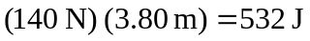 b) c) The normal force does no work.
d)
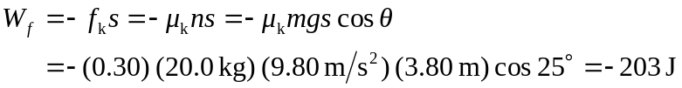
e) 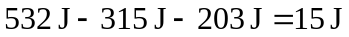 (14.7 J to three figures).
f) The result of part (e) is the kinetic energy at the top of the ramp, so the speed is

